1. 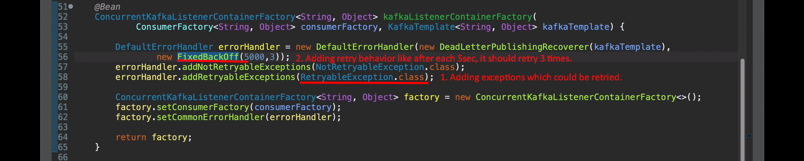  
   When all retries are done and still msg is not successfully processed (some exception is thrown out of @KafkaHandler), then the msg will be published to DTL.